**RFM ANALYSIS**

**/* RFM analysis, is a type of customer segmentation and behavioral targeting used to**

**help businesses rank and segment customers based on the recency,**

**frequency, and monetary value of a transaction.**

**— mailchimp.com/resources/rfm-analysis/ */**

select *

from customer_shopping_data;

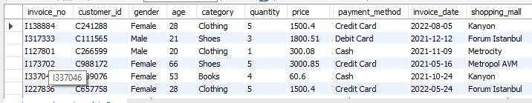

**-- inspect data**

**-- check how many records**

select count(*)

from customer_shopping_data;



**-- customer id has to be unique, check if it's correct**

select count(distinct(customer_id))

from customer_shopping_data;



**-- check if there are null values**

select *

from customer_shopping_data where shopping_mall is null;

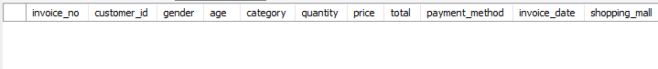

**-- let's add the total column**

ALTER TABLE customer_shopping_data ADD COLUMN total INT AFTER price;

UPDATE customer_shopping_data SET total = price * quantity;

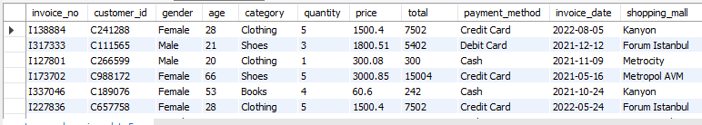

**-- spending by gender**

select gender, count(distinct(invoice_no)) orders, round(sum(total),2) sales

from customer_shopping_data

group by gender

order by 3 desc;



**-- most popular payment method among women and men**

select gender, round(sum(total),2) sales, payment_method

from customer_shopping_data

group by gender, payment_method

order by sales desc;

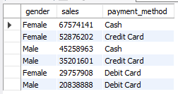

**-- spending by mall**

select shopping_mall, count(distinct(invoice_no)) orders, ROUND(sum(total),2) sales

from customer_shopping_data

group by shopping_mall

order by sales desc;

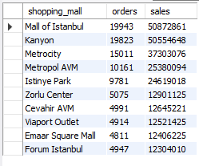

**-- spending by category**

select category , round(sum(total),2) sales

from customer_shopping_data

group by category

order by sales desc;

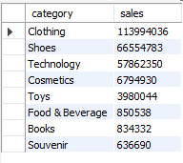

**-- spending by customer age groups**

SELECT

CASE

WHEN age < 20 THEN 'Under 20'

WHEN age BETWEEN 20 and 29 THEN '20 - 29'

WHEN age BETWEEN 30 and 39 THEN '30 - 39'

WHEN age BETWEEN 40 and 49 THEN '40 - 49'

WHEN age BETWEEN 50 and 59 THEN '50 - 59'

WHEN age BETWEEN 60 and 69 THEN '60 - 69'

WHEN age BETWEEN 70 and 79 THEN '70 - 79'

WHEN age >= 80 THEN 'Over 80'

END as age_range,

COUNT(*) AS customer_count, sum(total) as total

FROM customer_shopping_data

GROUP BY age_range

ORDER BY age_range,total desc;

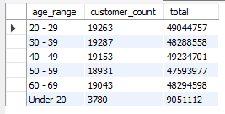

**-- top spending by year, gender wise**

select distinct(year(invoice_date)) year, gender, count(distinct(invoice_no)) total_invoices, round(sum(total),0) total_revenue

from customer_shopping_data

group by year, gender

order by total_revenue desc;

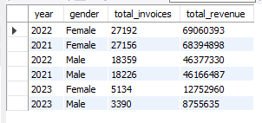

**-- top sales by year**

select distinct(year(invoice_date)) as year, sum(total) total_sales

from customer_shopping_data

group by year

order by total_sales desc;

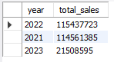

**-- top sales by months, year=2021**

select year(invoice_date) as year, monthname(invoice_date) as months, sum(total) as sales

from customer_shopping_data

group by year,months

having year=2021

order by sales desc;

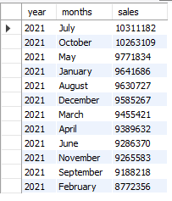

**-- top sales by months**

select monthname(invoice_date) as months, sum(total) as sales

from customer_shopping_data

group by months

order by sales desc;

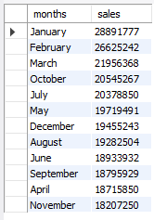

**-- different days between the last customer's purchase**

select

customer_id, gender, age, payment_method, shopping_mall,

datediff('2023-03-10', invoice_date) last_date_order,

count(distinct(invoice_no)) total_orders,

sum(price) spending

from customer_shopping_data

group by customer_id, gender, age, payment_method, shopping_mall, invoice_date

order by last_date_order;

with rfm as (

select

customer_id, gender, age, payment_method, shopping_mall,

datediff('2023-03-08', invoice_date) last_date_order,

count(distinct(invoice_no)) total_orders,

sum(price) spending

from customer_shopping_data

group by customer_id, gender, age, payment_method, shopping_mall, invoice_date

order by last_date_order

)

select *,

ntile(3) over (order by last_date_order) rfm_recency,

ntile(3) over (order by total_orders) rfm_frequency,

ntile(3) over (order by spending) rfm_monetary

from rfm;

with rfm as (

select

customer_id, gender, age, payment_method, shopping_mall,

datediff('2023-03-08', invoice_date) last_date_order,

count(distinct(invoice_no)) total_orders,

sum(price) spending

from customer_shopping_data

group by customer_id, gender, age, payment_method, shopping_mall, invoice_date

order by last_date_order

),

rfm_calc as (

select *,

ntile(3) over (order by last_date_order) rfm_recency,

ntile(3) over (order by total_orders) rfm_frequency,

ntile(3) over (order by spending) rfm_monetary

from rfm

order by rfm_monetary desc

)

select *, rfm_recency + rfm_frequency + rfm_monetary as rfm_score,

concat(rfm_recency, rfm_frequency, rfm_monetary) as rfm

from rfm_calc;

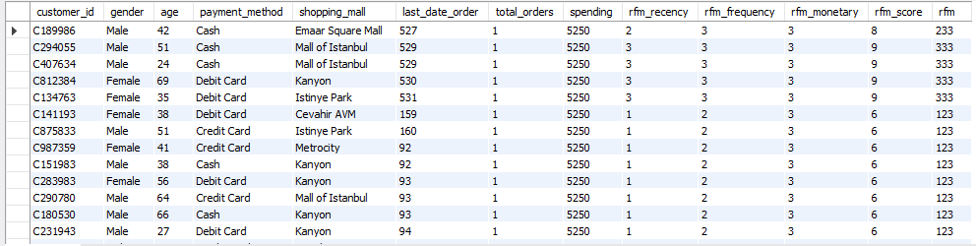

**-- RFM**

select *, case

when rfm in (311, 312, 311) then 'new customers'

when rfm in (111, 121, 131, 122, 133, 113, 112, 132) then 'lost customers'

when rfm in (212, 313, 123, 221, 211, 232) then 'regular customers'

when rfm in (223, 222, 213, 322, 231, 321, 331) then 'loyal customers'

when rfm in (333, 332, 323, 233) then 'champion customers'

end rfm_segment

from

(

with rfm as (

select

customer_id, gender, age, payment_method, shopping_mall,

datediff('2023-03-08', invoice_date) last_date_order,

count(distinct(invoice_no)) total_orders,

sum(price) spending

from customer_shopping_data

group by customer_id, gender, age, payment_method, shopping_mall, invoice_date

order by last_date_order

),

rfm_calc as (

select *,

ntile(3) over (order by last_date_order) rfm_recency,

ntile(3) over (order by total_orders) rfm_frequency,

ntile(3) over (order by spending) rfm_monetary

from rfm

order by rfm_monetary desc

)

select *, rfm_recency + rfm_frequency + rfm_monetary as rfm_score,

concat(rfm_recency, rfm_frequency, rfm_monetary) as rfm

from rfm_calc

) rfm_tb;

